

牛芯半导体（深圳）有限公司

**KNIULINK Co., Ltd.**

NS69993 Design Notes for rpcs.cmn Digital Block

Version 1.3

April 12, 2022

Revision History

|  |  |  |  |
| --- | --- | --- | --- |
| Ver. # | Rev. Date | Rev. By | Comment |
| 1.0 | 2022/2/25 | CaoHuiyang | Initial version |
| 1.1 | 2022/3/05 | CaoHuiyang | Add inter-structure and function |
| 1.2 | 2022/3/10 | CaoHuiyang | Supplement to reg_arbt |
| 1.3 | 2022/4/12 | CaoHuiyang | update |

**Contents**

NS69993 Design Notes for rpcs.cmn Digital Block 0

1 Spec/Function Requirement/Function Description 3

2 Signal Definition 4

3 Implementation Details 12

3.1 Clock & Reset 12

3.2 Hardware Implementation 12

3.2.1 cmn_creg 12

3.2.2 creg_ctl 15

3.2.3 reg_arbt 17

3.2.4 mem 20

3.2.5 mem_arbt 22

3.2.6 mem_reg0 23

3.2.7 mem_reg1 25

3.2.8 mem_reg2 25

3.2.9 mem_reg3 25

3.2.10 reg_mapping 26

3.3 Hardware summarize 27

4 User guide 28

4.1 Configuration Requirements 28

4.3 Registers 28

5 Special Note 28

6 FPGA Verification 28

7 Test Mode Strategy 28

8 Simulation List 28

# Spec/Function Requirement/Function Description

* Register Management and Mapping
* Lanes.fsm’s Memory and Memory Management
* Jtag/cr_apb_interface mux to cr_interface

# Signal Definition

|  |  |  |  |  |  |
| --- | --- | --- | --- | --- | --- |
| **Signal name** | | **I/O** | **From** | **To** | **Description/Function** |
| cr_ext_clk | | input | aon |  | cr external clock |
| cr_ext_clk_rst | | input |  | cr external clock reset· |
| cr_clk | | input |  | cr clock |
| cr_rst | | input |  | cr reset |
| phy_func_reset | | output |  | aon |  |
|  | |  |  |  |  |
| ref_range | | input | pcs_raw |  |  |
| rx_term_offset[4:0] | | input | pcs_raw |  | rx terminating resistor offset |
| txup_term_offset[8:0] | | input |  | rx pull-up resistor offset |
| txdn term_offset[8:0] | | input |  | rx pull-down resistor offset |
| rtune_req | | input |  | rtune require |
| fw_pwrup done_r | | output |  | aon | Send fw_pwrup_done_r to AON cmn for MPLL force/skip logic |
|  | |  |  |  |  |
| fw_rdy | | output |  | pcs_raw_lane | Generate fw_rdy signal to lanes  always high |
| pma_rx_term_offset  [4:0] | | output |  | pcs_raw->PMA | rx terminating resistor to pma |
| pma_txup_term_offset[8:0] | | output |  | rx pull-up resistor offset to pma |
| pma_txdn_term_offset[8:0] | | output |  | rx pull-down resistor offset to pma |
|  | |  |  |  |  |
| pma_rtune_req | | output |  | pcs_raw->PMA | Rtune require to pma |
|  | |  |  |  |  |
| cr_para seli | | input | aon |  | from aon block--jtag and apb_cr mux control signal(bus switch signal) |
| cr_para_addr[16:0] | | input | pcs_raw |  | CREG parallel interface（cr bus）  (from apb or jtag) |
| cr_para_wr_en | | input |  |
| cr_para_wr_data[16:0] | | input |  |
| cr_para_rd_en | | input |  |
| cr_para_rd_data[16:0] | | output |  | pcs_raw |
| cr_para_ack | | output |  |
| **Signal name** | | **I/O** | **From** | **To** | **Description/Function** |
| cr_cmn_aon sel[31:0] | output | |  | pcsraw_aon_cmn | aon register select control（decoding generated select to the registers in aon module） |
| cr_cmn_aon_sel2[31:0] | output | |  |
| cr_cmn_aon_rd_data[15:0] | input | | pcsraw_aon_cmn |  | aon register read back data（read back data from the registers in aon module） |
| Jtag_trst_n | input | | pcs_raw |  | Jtag reset |
| jtag_clk | input | | pcsraw_aon_cmn |  | Jtag clock |
| jtag_clk_n | input | |  | Jtag clock |
| jtag_tms | input | | pcs_raw |  | Jtag bus |
| jtag tdi | input | |  |
| jtag tdo | output | |  | pcs_raw |
| jtag tdo_en | output | |  |
| jtag_apb_sel | output | |  |  | If jtag_apb_sel=1,then apb be active |
| ovrd_clk_sel | output | |  | aon |  |
| ovrd_rst_sel | output | |  |  |
| phy_reset_ov | output | |  |  |
| txrx0_reset_ov | output | |  |  |
| txrx1_reset_ov | output | |  |  |
| txrx2_reset_ov | output | |  |  |
| txrx3_reset_ov | output | |  |  |
| scan_mode | input | | From pcs_raw and input aon at the same time |  |  |
| scan_shift | input | |  |  |
| scan shift_cg | input | |  |  |
| scan_set_rst | input | |  |  |

|  |  |  |  |  |
| --- | --- | --- | --- | --- |
| cr_addr[15:0] | output |  | Raw PCS lane and PMA registers | CREG parallel interface (for Raw PCS lane and PMA registers)  (to Raw PCS lane and PMA) |
| cr_wr_en | output |  |
| cr_wr_data[15:0] | output |  |
| cr_rd_en | output |  |
|  |  |  |  |  |
| cr_pma_rd_data[15:0] | input | PMA->pcs_raw |  | CREG read data from PMA |
| **Signal name** | **I/O** | **From** | **To** | **Description/Function** |
| cr0_rd_data[15:0] | input | Raw PCS lanes |  | CREG read data from Raw PCS lanes(lane0-3,lane4-7 no use) |
| cr1_rd_data[15:0] | input |  |
| cr2_rd_data[15:0] | input |  |
| cr3_rd_data[15:0] | input |  |
| cr4_rd_data[15:0] | input |  |
| cr5_rd_data[15:0] | input |  |
| cr6_rd_data[15:0] | input |  |
| cr7_rd_data[15:0] | input |  |

|  |  |  |  |  |
| --- | --- | --- | --- | --- |
| cr0_mem_ack | output |  | Raw PCS  lanes | CREG interface with Memory-Arbiter((memory bus be used by lane.fsm,  lane0-3,lane4-7 no use)) |
| cr1_mem_ack | output |  |
| cr2_mem_ack | output |  |
| cr3_mem_ack | output |  |
| cr4_mem_ack | output |  |
| cr5_mem_ack | output |  |
| cr6_mem_ack | output |  |
| cr7_mem_ack | output |  |
|  |  |  |  |
| cr0_mem_rd_data  [15:0] | output |  | Raw PCS lanes |
| cr1_mem_rd_data  [15:0] | output |  |
| cr2_mem_rd_data  [15:0] | output |  |
| cr3_mem_rd_data  [15:0] | output |  |
| Cr4_mem_rd_data  [15:0] | output |  |
| cr5_mem_rd_data  [15:0] | output |  |
| cr6_mem_rd_data  [15:0] | output |  |
| cr7_mem_rd_data  [15:0] | output |  |
|  |  |  |  |
| cr0_mem_req | input | Raw PCS lanes |  |
| cr1_mem_req | input |  |
| cr2_mem_req | input |  |
| cr3_mem_req | input |  |
| cr4_mem_req | input |  |
| cr5_mem_req | input |  |
| cr6_mem_req | input |  |
| cr7_mem_req | input |  |
|  |  |  |  |
| cr0_mem_addr[15:0] | input | Raw PCS lanes |  |
| cr1_mem_addr[15:0] | input |  |
| cr2_mem_addr[15:0] | input |  |
| cr3_mem_addr[15:0] | input |  |
| cr4_mem_addr[15:0] | input |  |
| cr5_mem_addr[15:0] | input |  |
| cr6_mem_addr[15:0] | input |  |
| cr7_mem_addr[15:0] | input |  |
|  |  |  |  |
| cr0_mem_wr_en | input | Raw PCS lanes |  |
| cr1_mem_wr_en | input |  |
| cr2_mem_wr_en | input |  |
| cr3_mem_wr_en | input |  |
| cr4_mem_wr_en | input |  |
| cr5_mem_wr_en | input |  |
| cr6_mem_wr_en | input |  |
| cr7_mem_wr_en | input |  |
|  |  |  |  |
| cr0_mem_wr_data  [15:0] | input | Raw PCS lanes |  |
| cr1_mem_wr_data  [15:0] | input |  |
| cr2_mem_wr_data  [15:0] | input |  |
| cr3_mem_wr_data  [15:0] | input |  |
| cr4_mem_wr_data  [15:0] | input |  |
| cr5_mem_wr_data  [15:0] | input |  |
| cr6_mem_wr_data  [15:0] | input |  |
| cr7_mem_wr_data  [15:0] | input |  |
|  |  |  |  |
| cr0_mem_rd_en | input | Raw PCS lanes |  |
| cr1_mem_rd_en | input |  |
| cr2_mem_rd_en | input |  |
| cr3_mem_rd_en | input |  |
| cr4_mem_rd_en | input |  |
| cr5_mem_rd_en | input |  |
| cr6_mem_rd_en | input |  |
| cr7_mem_rd_en | input |  |

|  |  |  |  |  |
| --- | --- | --- | --- | --- |
| cr0_reg_ack | output |  | Raw PCS lanes | CREG interface with Register-Arbiter  (The address generated by decoding is register map address exactly.) |
| cr1_reg_ack | output |  |
| cr2_reg ack | output |  |
| cr3_reg_ack | output |  |
| cr4_reg_ack | output |  |
| cr5_reg_ack | output |  |
| cr6_reg_ack | output |  |
| cr7_reg_ack | output |  |
|  |  |  |  |
| cr0_reg_rd_data[15:0] | output |  | Raw PCS lanes |
| cr1_reg_rd_data[15:0] | output |  |
| cr2_reg_rd_data[15:0] | output |  |
| cr3_reg_rd_data[15:0] | output |  |
| cr4_reg_rd_data[15:0] | output |  |
| cr5_reg_rd_data[15:0] | output |  |
| cr6_reg_rd_data[15:0] | output |  |
| cr7_reg_rd_data[15:0] | output |  |
|  |  |  |  |
| cr0_reg_req | input | Raw PCS lanes |  |
| cr1_reg_req | input |  |
| cr2_reg_req | input |  |
| cr3_reg_req | input |  |
| cr4_reg_req | input |  |
| cr5_reg_req | input |  |
| cr6_reg_req | input |  |
| cr7_reg_req | input |  |
|  |  |  |  |
| cr0_reg_addr[15:0] | input | Raw PCS lanes |  |
| cr1_reg_addr[15:0] | input |  |
| cr2_reg_addr[15:0] | input |  |
| cr3_reg addr[15:0] | input |  |
| cr4_reg_addr[15:0] | input |  |
| cr5_reg_addr[15:0] | input |  |
| cr6_reg_addr[15:0] | input |  |
| cr7_reg_addr[15:0] | input |  |
|  |  |  |  |
| cr0_reg_wr_en | input | Raw PCS lanes |  |
| cr1_reg_wr_en | input |  |
| cr2_reg_wr_en | input |  |
| cr3_reg_wr_en | input |  |
| cr4_reg_wr_en | input |  |
| cr5_reg_wr_en | input |  |
| cr6_reg_wr_en | input |  |
| cr7_reg_wr_en | input |  |
|  |  |  |  |
| cr0_reg_wr_data[15:0] | input | Raw PCS lanes |  |
| cr1_reg_wr_data[15:0] | input |  |
| cr2 reg_wr_data[15:0] | input |  |
| cr3_reg_wr_data[15:0] | input |  |
| cr4_reg_wr_data[15:0] | input |  |
| cr5_reg_wr_data[15:0] | input |  |
| cr6_reg_wr_data[15:0] | input |  |
| cr7_reg_wr_data[15:0] | input |  |

# Implementation Details

## Clock & Reset

**cr_ext_clk** be generated from **aon_cmn**,switch from **cr_jtag_clk** or **cr_para_clk** by **cr_para_sel_i** selected.

**cr_ext_clk_rst** be come from **phy_reset_i** is synchronized by **cr_ext_clk**.

**cr_rst** is synchronized by **cr_clk**,come from **aon_cmn**,be generated by **phy_reset_i** and **scan_set_rst**.

## Hardware Implementation

### cmn_creg

|  |  |  |  |  |
| --- | --- | --- | --- | --- |
| **Signal name** | **I/O** | **From** | **To** | **Description/Function** |
| cr_cmn_sel[31:0] | output |  | pcs_raw_cmn | pcs_raw_cmn interal regsiter select |
| cr_cmn_aon_sel[31:0] | output |  | pcs_raw_aon_cmn | pcs_raw_aon_cmn regsiter select |
| cr_cmn_aon_sel2[31:0] | output |  | pcs_raw_aon_cmn | pcs_raw_aon_cmn regsiter select |
|  |  |  |  |  |
| cr_clk | input | pcs_raw_cmn |  | cr clock |
| cr_rst | input | pcs_raw_cmn |  | cr reset |
| cr_addr[15:0] | input | pcs_raw_cmn |  | cr address bus(is register map address exactly) |

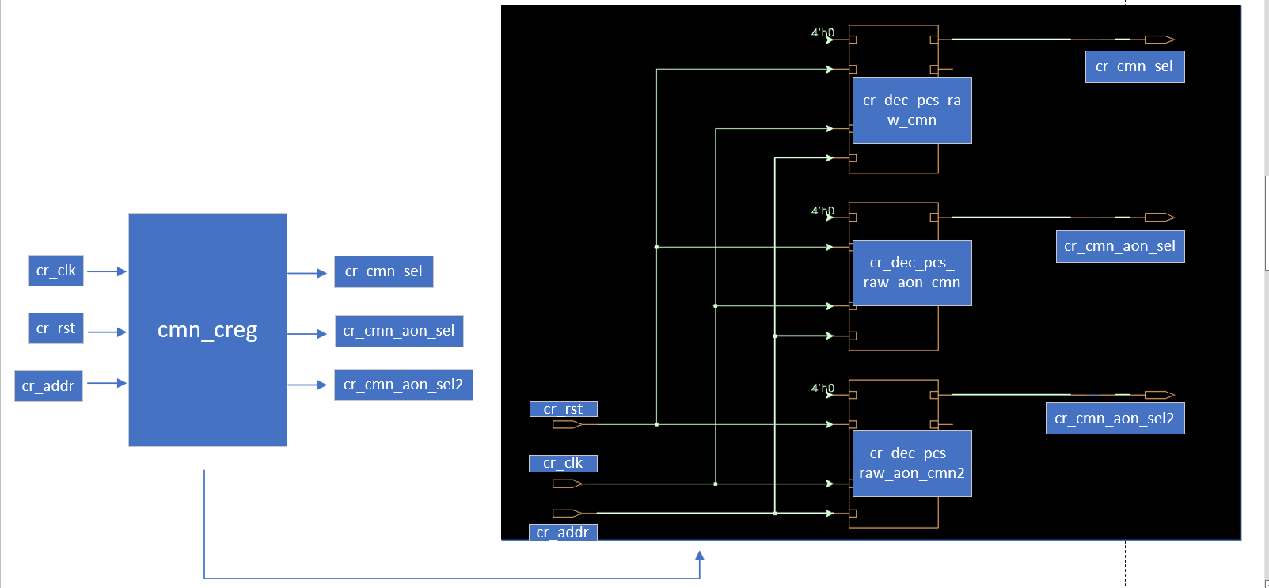

As shown in FIG, **cmn_creg** module include **cr_dec_pcs_raw_cmn** module/**cr_dec_pcs_raw_aon_cmn** module and **cr_dec_pcs_raw_aon_cmn2** module.

The function of the **cmn_creg** module is to use **cr_addr** to generate the **pcs_raw_cmn** module’s internal registers chip select and the **pcs_raw_aon_cmn** module’s registers chip select.

The function of the **cr_dec_pcs_raw_cmn** module is to use **cr_addr** to decoding and generate the **cr_cmn_sel[31:0]** that is signal of chip select.

The function of the **cr_dec_pcs_raw_aon_cmn** module is to use **cr_addr** to decoding and generate the **cr_cmn_aon_sel[31:0]** that is signal of chip select.

The function of the **cr_dec_pcs_raw_aon_cmn2** module is to use **cr_addr** to decoding and generate the **cr_cmn_aon_sel2[31:0]** that is signal of chip select.

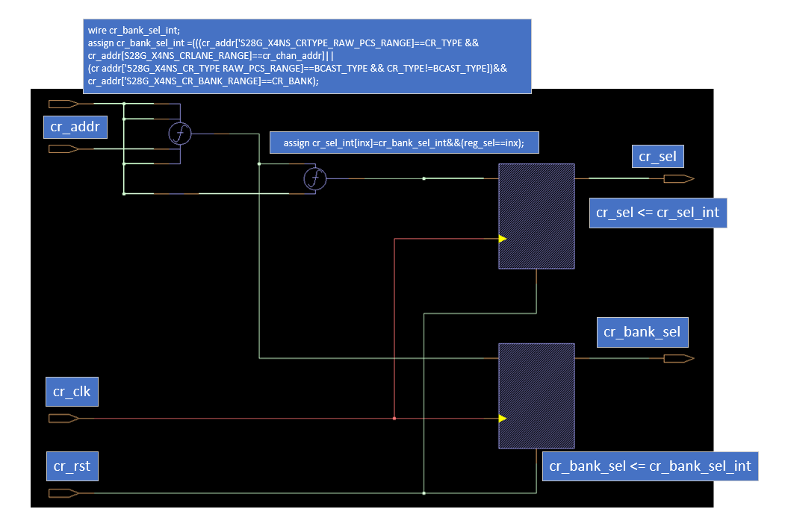

The interal structure of **cr_dec_pcs_raw_cmn/cr_dec_pcs_raw_aon_cmn/cr_dec_pcs_raw_aon_cmn2** modules are the same as shown in FIG,

After latching,the **cr_addr** generated **cr_sel** and **cr_bank_sel** by the decoding function **f1** and **f2**. In which **cr_bank_sel_int** is the register bank chip select signal,**reg_sel = cr_addr[4:0]** is the number of registers in every modules. The **cr_sel_int** is the one-hot code represent of **reg_sel**. The **cr_bank_sel** not be used, **cr_sel** connected to the every correspond modules through three different buses,when **cmn_creg** module instanted into **cr_dec_pcs_raw_cmn/cr_dec_pcs_raw_aon_cmn/cr_dec_pcs_raw_aon_cmn2** modules.

### creg_ctl

|  |  |  |  |  |
| --- | --- | --- | --- | --- |
| **Signal name** | **I/O** | **From** | **To** | **Description/Function** |
| cr_para_sel_i | input | cmn |  | APB OR JTAG SELECT |
|  |  |  |  |  |
| cr_para_addr[15:0] | input | cmn |  | CR Parallel Interface |
| cr_para_wr_en | input |  |
| cr_para_wr_data[15:0] | input |  |
| cr_para_rd_en | input |  |
| cr_para_rd_data[15:0] | output |  | cmn |
| cr_para_ac | output |  |
|  |  |  |  |  |
| jtag_rst | input | jtag_ctl |  | JTAG Register interface |
| jtag_clk | input |  |
| jtag_clk_n | input |  |
| jtag_capture | input |  |
| jtag_shift | input |  |
| jtag_update | input |  |
| jtag_ser_in | input |  |
| jtag_crsel_sel | input |  |
| jtag_crsel_tdo | output |  | jtag_ctl |
|  |  |  |  |  |
| cr_addr[15:0] | output |  |  | Internal CREG interface |
| cr_wr_en | output |  |
| cr_wr_data[15:0] | output |  |
| cr_rd_en | output |  |
| cr_rd_data[15:0] | input |  |  |
| cr_ack | input |  |  |

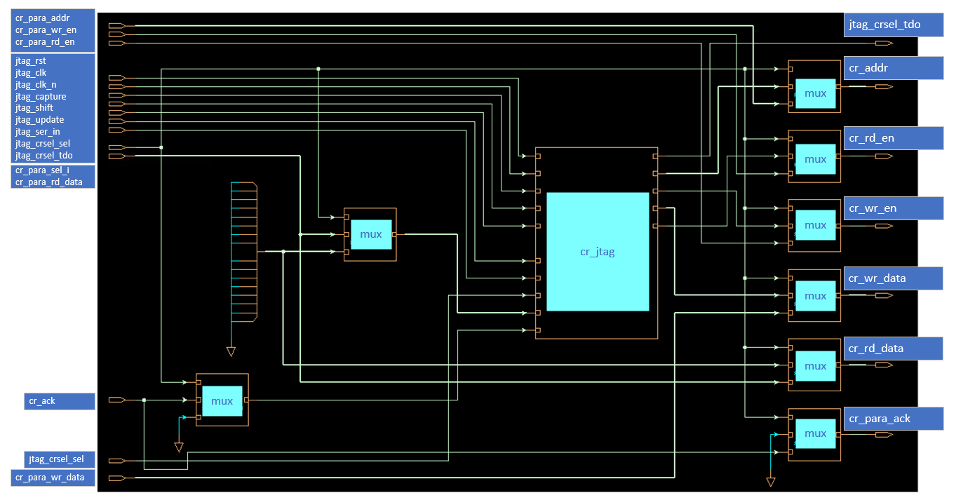

The **creg_ctl** module include **creg_jtag** module,**cr_addr_mux** module,**cr_wr_data_mux** module,**cr_wr_en_mux** module,**cr_rd_en_mux** module,**cr_para_rd_data_mux** module,**cr_para_ack_mux** module,**cr_jtag_rd_data_mux** module and **cr_jtag_ack_mux** module.

The function of the **cmn_creg** module is switching **CR Parallel Interface**(default interface) and **JTAG Register interfac** to generate **Internal CREG interface** which process controled by **cr_para_sel_i** signal.

The function of the **creg_jtag** module is changing **JTAG Register interface** into **cr interfac**.

The function of the **cr_addr_mu** module is switching **cr_jtag_addr** and **cr_para_addr** to generate **cr_addr** which process controled by **cr_para_sel_i** signal.

The function of the **cr_wr_data_mux** module is switching **cr_jtag_wr_data** and **cr_para_wr_data** to generate **cr_wr_data** which process controled by **cr_para_sel_i** signal.

The function of the **cr_wr_en_mux** module is switching **cr_jtag_wr_en** and **cr_para_wr_en** to generate **cr_wr_en** which process controled by **cr_para_sel_i** signal.

The function of the **cr_rd_en_mux** module is switching **cr_jtag_rd_en** and **cr_para_rd_en** to generate **cr_rd_en** which process controled by **cr_para_sel_i** signal.

The function of the **cr_para_rd_data_mux** module is switching **0** and **cr_rd_data** to generate **cr_para_rd_data** which process controled by **cr_para_sel_i** signal.

The function of the **cr_para_ack_mux** module is switching **0** and **cr_ack** to generate **cr_para_ack** which process controled by **cr_para_sel_i** signal.

The function of the **cr_jtag_rd_data_mux** module is switching **0** and **cr_rd_data** to generate **cr_jtag_rd_data** which process controled by **cr_para_sel_i** signal.

The function of the **cr_jtag_ack_mux** module is switching **0** and **cr_ack** to generate **cr_jtag_ack** which process controled by **cr_para_sel_i** signal.

### reg_arbt

|  |  |  |  |  |
| --- | --- | --- | --- | --- |
| **Signal name** | **I/O** | **From** | **To** | **Description/Function** |
| cr_clk | input |  |  | Clock and Reset |
| cr_rst | input |  |  |
|  |  |  |  |  |
| cr_req[15:0] | input |  |  | CR input interfaces  (Combine the 16 cr interfaces into a 256-bit bus input, the address is the reg map address) |
| cr_addr[255:0] | input |  |  |
| cr_wr_data[255:0] | input |  |  |
| cr_wr_en[15:0] | input |  |  |
| cr_rd_en[15:0] | input |  |  |
| cr_op_xtnd[15:0] | input |  |  |
| cr_ack[15:0] | output |  |  |
| cr_rd data[15:0] | output |  |  |
|  |  |  |  |  |
| cr_arbt_addr[15:0] | output |  |  | CR output interface(cr_interface output after switch,the address is the reg map address） |
| cr_arbt_wr_data[15:0] | output |  |  |
| cr_arbt_wr_en | output |  |  |
| cr_arbtrd_en | output |  |  |
| cr_arbt rd_data[15:0] | input |  |  |

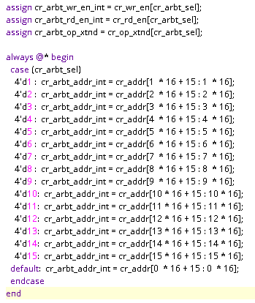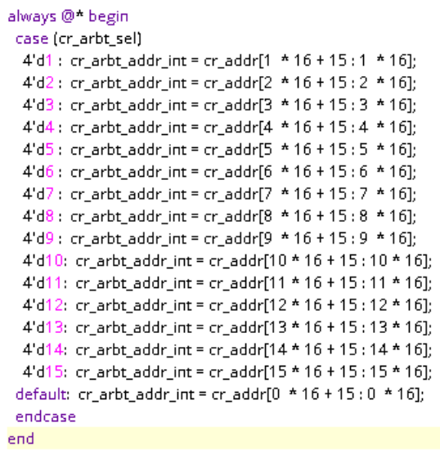

As shown above, **cr_arbt_sel (cr_arbt_sel_int)** determines which **cr interface** is selected.

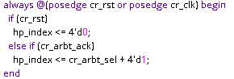

As shown above,if the current interface is selected,the value of **hp_index** is the current selection value plus 1(**cr_arbt_sel**+1).

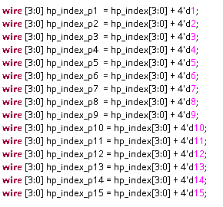

The above code indicates that **hp_index_p1...hp_index_p15** is the value of **hp_index** plus 1..15, that is, the 16 interfaces is cyclically shifted left arrange from low to high based on the current be selected interface value.

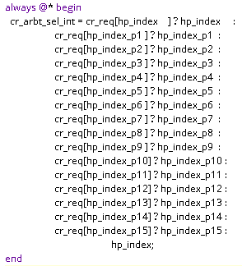

Above code is the **cr_arbt_sel_int** value generated process. Based on **hp_index**, search for the position of **cr_req[x]** where 1 first appears from low to high in the 16 interfaces(hp_index->hp_index_p1->hp_index_p2...->hp_index_p14->hp_index_p15) ,the search process follows a round-robin selection pattern. If 1 is found, that interface is selected(**cr_arbt_sel_int=hp_index_px**), if **cr_req=0** (no request occurs) , **cr_arbt_sel_int=hp_index** (the current selected interface number value plus 1).

In summary, the function of the **reg_arbt** module is to determine which of the 16 **CR input interfaces** is used as the **CR output interface** according to the value of **cr_arbt_sel**, and **cr_arbt_sel** is generated by **cr_req** decoding. Specific process is the process of looping to the left to search the first be requested interface based on the currently selected interface.If cr_req=0 (no request occurs), then cr_arbt_sel_int=hp_index (that is, the current selection path value plus 1).

In this design, 4 interfaces are used, so the **reg_arbt** module realizes the process of converting 4 **cr input interface** parallel input to 1 **CR output interface** serial output.

### mem

|  |  |  |  |  |
| --- | --- | --- | --- | --- |
| **Signal name** | **I/O** | **From** | **To** | **Description/Function** |
| cr_c1k | input |  |  | Mem clock |
| cr_rst | input |  |  | Mem reset |
|  |  |  |  |  |
| cr_cmn[63:0]_b[7:0]_sel[31:0] | input | mem_creg[3:0] |  | register select in mem |
|  |  |  |  |  |
| cr_wr_en | input |  |  | register write enable in mem |
| cr_wr_data[15:0] | input |  |  | register write data in mem |
| cr_rd_en | input |  |  | register read enable in mem |
| cr_rd data[15:0] | output |  | Raw PCS lanes | register read data in mem |

The **mem** make up **cmn[63:0]_b[7:0], b[7:0]** represent 8 mem banks, and **cmn[63:0]** represent 64 mem blocks, each mem block include 32 16bit registers, So if use 4 mem blocks, the memory size is 64（block）*32（register）*4（bank）=8192 registers (16bit). The memory unit is the register and the specific operation is as follows.

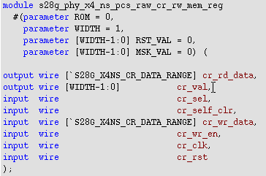

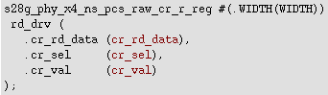

### mem_arbt

The interface and function of the **mem_arb** module is the same as **reg_arbt** module.The differnent is the input and output interface of **mem_arb** module is data and address of **mem**.

### mem_reg0

|  |  |  |  |  |
| --- | --- | --- | --- | --- |
| **Signal name** | **I/O** | **From** | **To** | **Description/Function** |
| cr_ck | input |  |  | mem clock |
| cr_rst | input |  |  | mem reset |
| cr_addr | input | Raw PCS lanes |  | mem address |
|  |  |  |  |  |
| cr_cmn[15:0]_b[7:0]_sel | output |  | mem | register select in mem |

The function of the **mem_reg** module is to generate the chip select signal of **cmn[15:0]_b[7:0][31:0]** by decoding **cr_addr[15:0]** (**cr_addr** external connection **cr_mem_addr**).

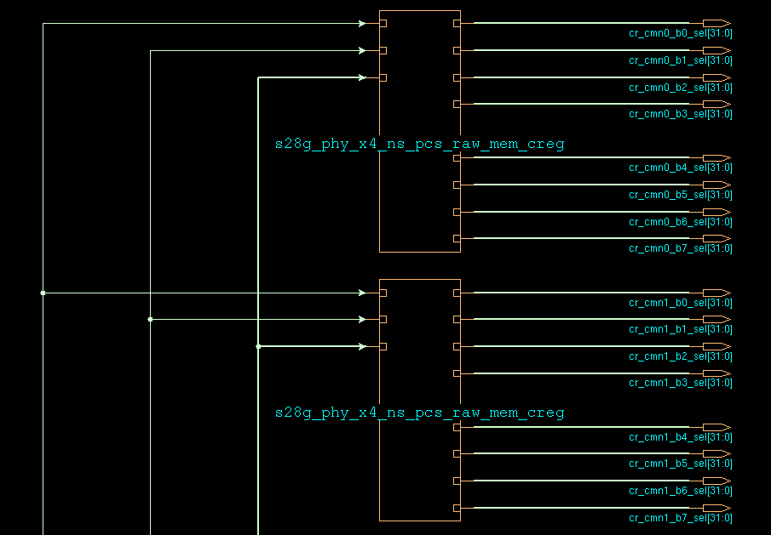

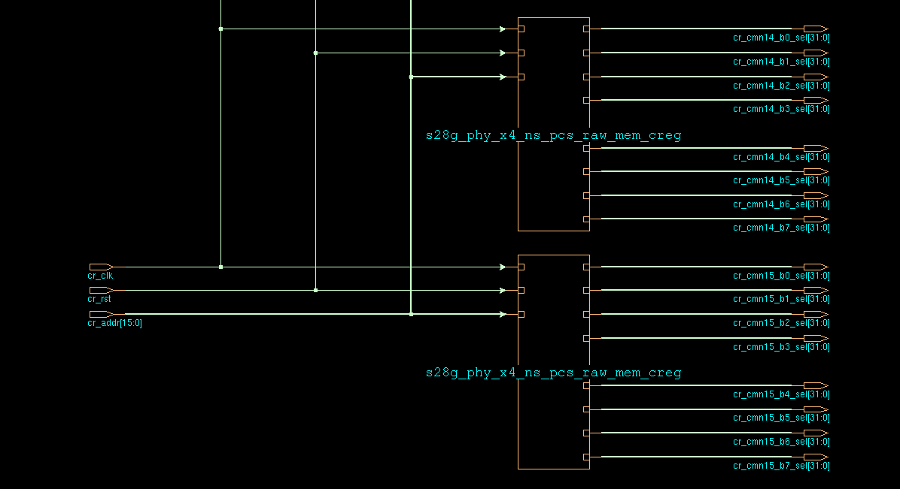

The picture above is cmn0_creg~cmn15_creg (block select signal generate), and the lower picture is the internal structure of cmnX_creg (bank select signal generate).

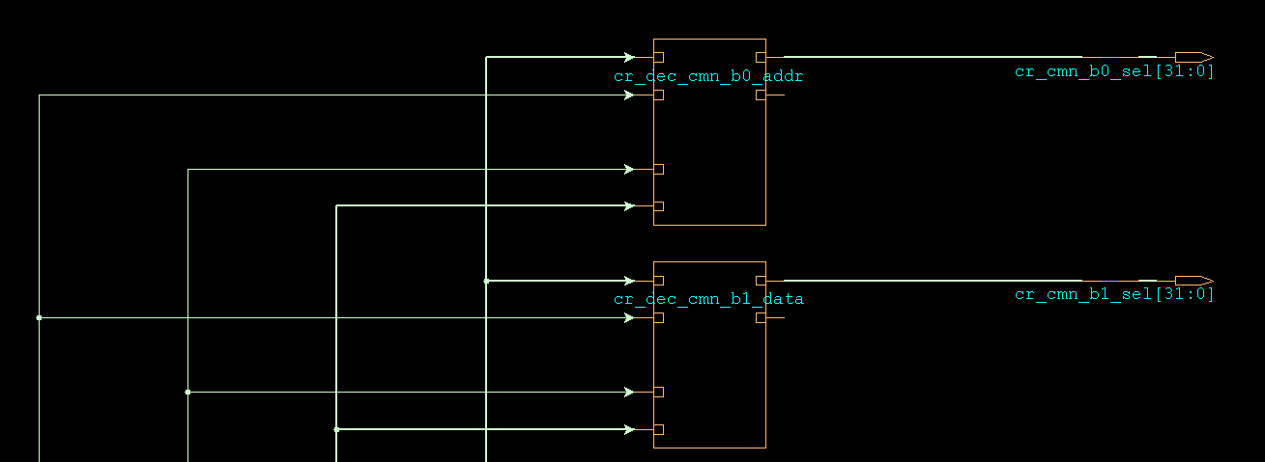

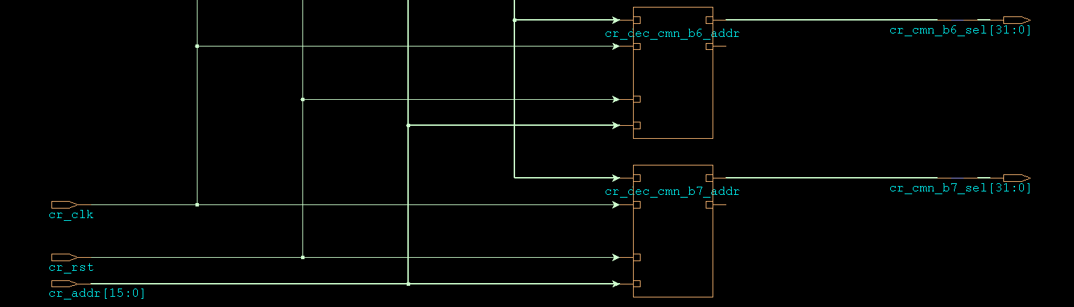

The internal structure of c**r_dec_cmn_bx_addr** module is the same as **cr_dec_pcs_raw_cmn/cr_dec_pcs_raw_aon_cmn/cr_dec_pcs_raw_aon_cmn2** modules.

### mem_reg1

The interface and internal structure are the same as above.

Generate **cmn[31:16]_b[7:0]** chip select.

### mem_reg2

The interface and internal structure are the same as above.

Generate **cmn[47:32]_b[7:0]** chip select.

### mem_reg3

The interface and internal structure are the same as above.

Generate **cmn[63:48]_b[7:0]** chip select.

### reg_mapping

|  |  |  |  |  |
| --- | --- | --- | --- | --- |
| **Signal name** | **I/O** | **From** | **To** | **Description/Function** |
| i_cr_para_addr[15:0] | input |  |  | cr_para_add before mapping |
| i_cr para_rd data[15:0] | input |  |  | cr para_rd data before mapping |
| i_cr para wr_data[15:0] | input |  |  | cr para wr_data before mapping |
|  |  |  |  |  |
| o_cr para addr[15:0] | output |  |  | cr_para_add after mapping |
| o_cr para rd data[15:0] | output |  |  | cr para_rd data after mapping |
| o_cr para_wr_data[15:0] | output |  |  | cr para wr_data after mapping |

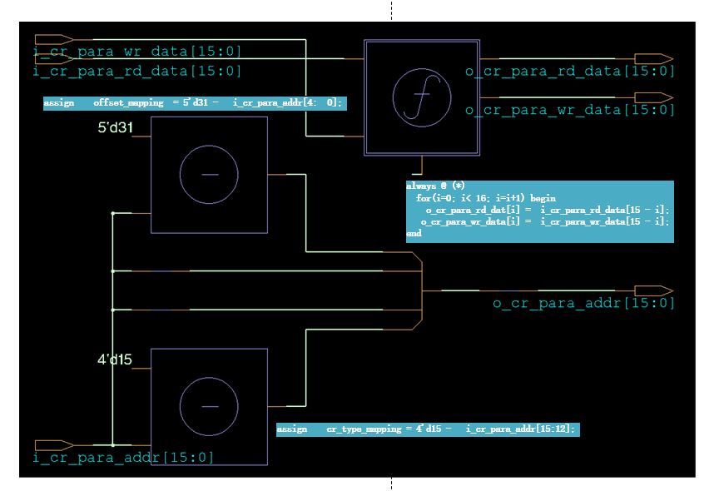

As shown in the figure, the main function of **reg_mapping** is to complete the mapping operation of **cr_para_add/cr_para_rd_data/cr_para_wr_data**.

## Hardware summarize

cr_ para_ addr[15:12]=4'b0101,PHY broadcasts to all PMA lanes.

cr_para_ addr[15:12]=4b0110, PHY broadcasts to all RAW PCS lanes.

cr_para_ addr[15:12]=4b0111, PHY broadcasts to all RAW PCS AON lanes.

The registers can be operated by firmware/jtag/apb.

Frimware operate register flow:1.Xlane.fsm get order and operate data through cr[7:0]_mem_bus ❶ ;2. Xlane.fsm complete register operate with reg_arbt through cr[7:0]_reg_bus❷;2. reg_arbt complete register operate with registers in every module through cr_bus❸ ;



# User guide

## 4.1 Configuration Requirements

## 4.3 Registers

# Special Note

# FPGA Verification

# Test Mode Strategy

# Simulation List